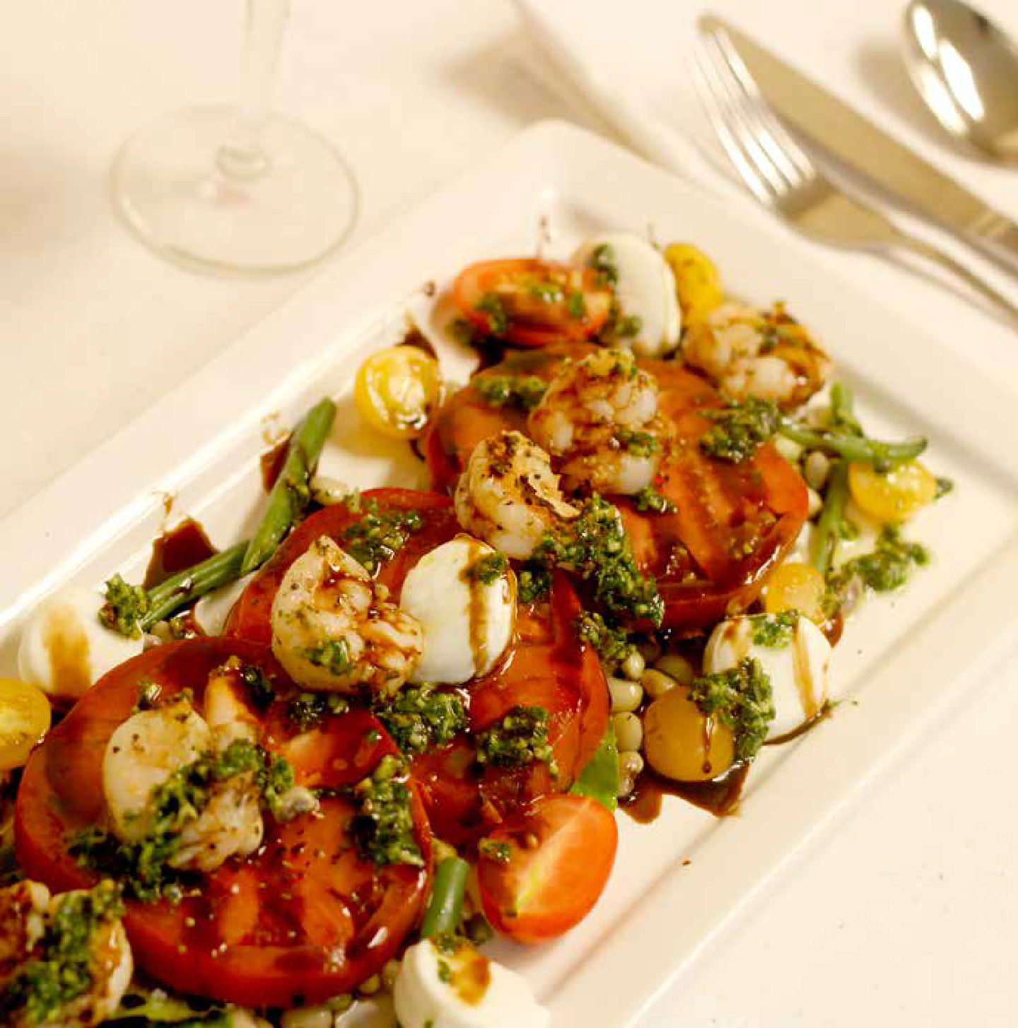

C A T E R I N G
- MENU -

B R E A K F A S T • L U N C H • D I N N E R •

E X E C U T I V E C H E F : J A M E S W A S H I N G T O N

S A L E S & C A T E R I N G : L I N D A H A R R I S

G E N E R A L M A N A G E R : S O N J A N E T T A H O U S T O N

CLASSIC CONTINENTAL 10.00 pp

Assorted Breakfast Breads and Pastries Butter and Jams
Bagels and Cream Cheese Fresh Fruit Juices
Coffees and Teas
EXECUTIVE CONTINENTAL 12.00 pp

Assorted Breakfast Breads and Pastries Butter and Jams
Bagels and Cream Cheese
BRIDGE BREAKFAST BUFFET
Assorted Breakfast Breads and Pastries Butter and Jams
Bagels and Cream Cheese
Sliced Fresh Fruit and Berries Scrambled Eggs
Bacon and Sausage
Breakfast Potatoes or Grits
Assorted Cold Cereals and Milk Fresh Fruit Juice
Coffees and Teas
14.00pp

Sliced Fresh Fruit and Berries Fresh Fruit Juices
Coffees and Teas

Upgrades
Assorted Fruits and Yogurt 1.50 each Assorted Cold Cereals& Milk 1.50 each
Granola Bars 1.50 each/pp
PLATED BREAKFAST* 10.00 pp

All American Breakfast
Scrambled Eggs, Bacon, and Sausage Links Grits or Breakfast Potatoes
Wheat Toast or Biscuit
EXECUTIVE BREAKFAST 17.00 pp

Assorted Breakfast Breads and Pastries Butter and Jams
Bagels and Cream Cheese
Sliced Fresh Fruit and Berries
Scrambled Eggs • Bacon and Sausage Breakfast Potatoes or Grits
Assorted Cold Cereals and Milk French Toast with Syrup
Pancakes with Syrup Fresh Fruit Juices
Coffees and Teas

*All plated breakfasts are served with Coffee, Tea, and or Orange Juice

BUFFET LUNCH ENTREE SELECTIONS
- CHOOSE ONE OPTION -
Southwest Grilled Chicken Breast with Tomato & Roasted Corn Salsa and Orzo Salad Grilled Chicken Breast with Pesto, Penne and Parmesan
Grilled salmon with Caper Beurre Blanc and Rice Pilaf Pecan-Crusted Chicken Breast with Ginger-Peach Glaze
Chicken Roulade with Spinach and Mushrooms and Sundried Tomato Sauce
Tilapia Almondine
Cornmeal-Fried Catfish with Remoulade
Sliced Flat Iron Steak with Peppercorn Mushroom Sauce and Au Gratin Potatoes Homestyle Turkey Meatloaf
Burgundy Beef Tips and Rice
Beef or Chicken Fajitas with Peppers and Onions and Flour Tortillas Herb Roasted Pork Loin with Balsamic Stewed Peppers and Onions Vegetarian Lasagna with 3 Cheeses
20.00 pp
(Includes up to 2 sides)
All entrees are served with a Simple Salad, Rolls and Butter, Coffee, or Iced Tea
100 MIKE MOORE BLVD • BIRMINGHAM, AL 35224 • (205) 380-2990
EMAIL - BRIDGEEVENTS@THEBRIDGEONLINE.ORG • WWW.THEBRIDGEONLINE.ORG

DELI LUNCH BUFFET 14.00 pp
Soup of the Day
Deli Tray to Include: Roast Beef, Turkey, and Ham Tray of Cheese to Include: Swiss and Cheddar
Variety of Breads • Lettuce, Tomato and Pickles Mayonnaise, Mustard
One Composed Salad or Fruit Salad
Potato Chips • Cookies or Brownies • Iced Tea, Coffee
EXPRESS LUNCHEON BUFFET 17.00 pp
Soup of the Day
Choice of One Hot Entrée
Minestrone, Tomato Basil, Chicken Tortilla Chef’s Choice of Starch and Vegetables
One Composed Salad or Fruit Salad
Rolls and Butter • Cookies or Brownies • Iced Tea, Coffee

**Buffets are for parties of 15 or more. A surcharge of $3pp will apply to groups less than 15 persons.

SOUPS & SALADS
CHEF’S SOUP OF THE DAY 3.00 pp SIGNATURE TUSCAN SALAD 8.00 pp

Minestrone, Tomato Basil, or Chicken Tortilla

SIMPLE MIXED GREEN SALAD 5.00 pp

Tomatoes, Carrots, and Cucumbers w/Balsamic Vinaigrette

ICEBERG WEDGE SALAD 7.00 pp

Avocado, Tomatoes, and Applewood Smoked Bacon w/Blue Cheese Dressing

Served with blueberries, strawberries, grapes, mandarin oranges, pecans and purple onions.

CAESAR SALAD 8.00 pp

With Fried Capers, Soft Boiled Egg and Shaved Parmesan

Grilled Chicken may be added on All Plated Soups or Salad Entrees. 3.00pp

LUNCH OR DINNER BUFFET

Almond-Crusted Tilapia
Mandarin Orange Glaze, Sautéed French Green Beans and Rice Pilaf
18.00 pp
Baked Tilapia with Herb Breadcrumbs
Citrus Beurre Blanc, Rice Pilaf and Asparagus Spears
18.00 pp
The Bridge Lump Crab Cakes (2 - 5 oz.)
Roasted Red Pepper Coulis, Garlic Mashed Potatoes and Sautéed Asparagus
27.00 pp
Grilled Ribeye or New York Strip Steak
Blue Cheese Merlot Sauce, Yukon Gold Mashed Potatoes and Sautéed Spinach
34.00 pp
Beef Tenderloin
Mushroom-Madeira Sauce, Fried Shallots, Potatoes Au Gratin and Asparagus
32.00 pp

100 MIKE MOORE BLVD • BIRMINGHAM, AL 35224 • (205) 380-2990
EMAIL - BRIDGEEVENTS@THEBRIDGEONLINE.ORG • WWW.THEBRIDGEONLINE.ORG

COMBINATION BUFFET ENTREES
- SERVED WITH CHEF’S CHOICE OF STARCH AND VEGETABLES -

Chicken Picatta and Herb Baked Tilapia
23.00 pp
Pecan Crusted Chicken and Grilled Salmon
27.00 pp
Crab Cake and Herb Baked Tilapia
27.00 pp
Grilled Tenderloin of Beef and Chicken Roulade
27.00 pp
Grilled Tenderloin of Beef and Almond-Crusted Tilapia
30.00 pp
Grilled Tenderloin of Beef and Grilled Salmon
32.00 pp
All entrees are served with a Simple Salad, Rolls and Butter, and Peach or Sweet Tea

BUFFET DINNERS
- FOR PLATED ADD $10.00PP -

$18.95 pp $21.95 pp

Chicken Sauté or Grilled Chicken Starch (Mashed Potatoes/Rice Pilaf)
Vegetable (Sautéed, Green Beans) Garden Salad
Fresh Rolls
Sweet or Peach Tea
$22.95 pp
Shrimp and Grits Catfish
Fried Chicken
Starch (Potatoes/ Rice Pilaf)
Vegetable (Medley, Green Beans) Garden Salad or Coleslaw
Fresh Rolls
Sweet or Peach Tea
Chicken Sauté and Grilled Salmon Starch (Mashed Potatoes/Rice Pilaf)
Vegetable (Sautéed, Green Beans) Garden Salad
Fresh Rolls
Sweet or Peach Tea

$26.95 pp
Chicken Sauté Salmon
Shrimp and Grits Prime Rib
Starch (Hoppin John or Rice Pilaf) Vegetable (Medley, Green Beans) Garden Salad
Fresh Rolls
Sweet or Peach Tea

100 MIKE MOORE BLVD • BIRMINGHAM, AL 35224 • (205) 380-2990
EMAIL - BRIDGEEVENTS@THEBRIDGEONLINE.ORG • WWW.THEBRIDGEONLINE.ORG

BUFFET DINNERS
- CONTINUED -

$20.00 pp
Pan Seared Asian Chicken Breast Teriyaki Sesame Glaze
Jasmine Rice and Julienne Vegetables
$20.00 pp
Pecan Crusted Chicken Ginger Peach Glaze
Rice Pilaf and Julienne Vegetables
$23.00 pp
Chicken Roulade Choice of:
Sautéed Spinach, Mushroom Marsala Sauce or Sun-dried Tomato and Artichoke Heart Relish
And Roasted Potatoes
$22.00 pp
Sliced Roasted Pork Loin
Sun-Dried Cherry Compote
Mashed Sweet Potatoes and Sautéed Spinach
$18.00 pp
Almond-Crusted Tilapia
Smoke Tomato Beurre Blanc
French Green Beans and Rice Pilaf
$25.00 pp
Grilled Atlantic Salmon Caper Meniere Sauce
Roasted Garlic Mashed Potatoes and Asparagus

All entrees are served with a Simple Salad, Rolls, and Peach or Sweet Tea

SIDE ITEMS DESSERTS

ADDITIONAL SELECTIONS
Rosemary Roasted Potatoes Potatoes Au Gratin
Roasted Fingerling Potatoes Garlic Mashed Potatoes Mashed Sweet Potatoes
Sautéed Seasonal Vegetables Medley Green Beans
Ginger-Glazed Carrots
Yellow Squash Casserole Roasted Brussel Sprouts
Roasted Broccoli and Cauliflower Honey Roasted Root Vegetables
Ratatouille
$7.00pp
New York Style Cheesecake with Marinated Strawberries
White Chocolate and Seasonal Fruit Bread Pudding with Lemon Anglaise Sauce
Marinated Strawberries in Puff Pastry
Served with Vanilla Bean Whipped Cream
$4.00pp
Peach Cobbler Chocolate Cake
Key Lime Cake or Pie Apple Crisp
Red Velvet Cake Caramel Cake Pecan Pie
Fried Apple Pies

100 MIKE MOORE BLVD • BIRMINGHAM, AL 35224 • (205) 380-2990
EMAIL - BRIDGEEVENTS@THEBRIDGEONLINE.ORG • WWW.THEBRIDGEONLINE.ORG

SELECTIONS

PARTY, MOCK-TAIL OR RECEPTION
QUANTITY: 100 PIECES FOR SETLECTIONS BELOW SERVES 50-75 PEOPLE

Assorted Wings (Choice of 2 sauces) 100.00

Meatballs in spicy BBQ sauce (White BBQ & Traditional BBQ)
115.00

Chilled Shrimp Cocktail 180.00

Fried Shrimp 180.00

Southern Stuffed Eggs 75.00

Assorted Tray - Cheese and Crackers (Domestic Cheese Tray) 155.00

Seasonal Fruit Tray 115.00

Vegetable Crudité 105.00

Fried Mushrooms 75.00

Pasta Salad 75.00

100 MIKE MOORE BLVD • BIRMINGHAM, AL 35224 • (205) 380-2990
EMAIL - BRIDGEEVENTS@THEBRIDGEONLINE.ORG • WWW.THEBRIDGEONLINE.ORG

DIPS

SERVED WITH PITA CHIPS, BAGEL CHIPS, AND CRACKERS

Hummus
2.00 pp

Hot Spinach and Artichoke Dip
3.00 pp

Deviled Crab Dip
7.00 pp

Formal Punch
20.00 per gallon

PARTY APPETIZERS

CHOICE OF TWO 10.00pp
Smoked Salmon
Chopped Eggs, Capers, Dill, Cream Cheese and Red Onions

Fresh Mozzarella and Vine Ripened Tomato Bruschetta With Balsamic Reduction and Extra Virgin Olive Oil

Gulf Shrimp and Corn Fritter with Homemade Tartar Sauce
The Bridge Crab Bake with Remoulade Sauce
Roasted Pork Crostini with Mango Peach Chutney

100 MIKE MOORE BLVD • BIRMINGHAM, AL 35224 • (205) 380-2990
EMAIL - BRIDGEEVENTS@THEBRIDGEONLINE.ORG • WWW.THEBRIDGEONLINE.ORG

PARTY APPETIZERS

CHOICE OF TWO
8.00pp

Array of Deluxe Canapes Assorted Finger Sandwiches
Pepper-Seared Beef Tenderloin Crostini Mediterranean Chicken Skewers
Assorted Bruschetta and Crostini

Smoked Trout Bruschetta with Lemon Dill Crème

REHEARSAL DINNER MENU

Rehearsal Dinner Menus are for parties of 20 people or more. For groups of less than 20 people, a $3.00pp surcharge will apply.

Served with Simple Salad, Rolls, and Beverage

CHOICE OF ONE 15.00pp

Herb Roasted Chicken
Served with Green Beans and Garlic Mashed Potatoes

Chicken Tetrazzini
Made with Peppers, Onions, Mushrooms and Three Cheeses

Baked Lasagna or Baked Spaghetti (Add $3.00pp for Turkey)

Grilled, Baked, or Fried Tilapia with Rice Pilaf and Green Beans

Stuffed Bell Pepper
Made with Beef, Aromatics, Rice, Three Cheeses, and Marinara Sauce

100 MIKE MOORE BLVD • BIRMINGHAM, AL 35224 • (205) 380-2990
EMAIL - BRIDGEEVENTS@THEBRIDGEONLINE.ORG • WWW.THEBRIDGEONLINE.ORG

SPECIALTY STATIONS

Priced Per Person, Minimum 25 people Stations can be Self-Serve or $75 Per Attendant

Pasta Station
Select Two Pastas and Pair with Two Sauces: Pastas: Penne, Farfalle, Fettuccini
Sauces: Marinara, Alfredo, Pesto Cream
Served with Grated Parmesan Cheese, Crumbled Bacon and Green Onion
6.00 pp

Mashed Potato Martini Bar
Idaho Mashed Potatoes Served in a Martini Glass
Served with Sour Cream, Green Onions, Shredded Cheese, Bacon Bits Select Two Toppings:
Burgundy Beef Tips, Broccoli Cheddar Sauce
10.00 pp

Shrimp and Grits Station Southern Style Grits
10.00 pp

Asian Stir Fry Station
Chicken and Beef with Soy Ginger Garlic Sauce
Julienne Vegetables, Fried Rice, Sesame Seeds, Fortune Cookies and Chop Sticks
12.00 pp

CARVING STATIONS
Priced Per Person, Minimum 25 people. $75 per Carving Attendant

Roasted Turkey Breast
3.00 pp

Sweet Mustard and Bourbon Glazed Ham
3.00 pp

Honey Soy Glazed Roasted Pork Loin
4.00 pp

Herb-Roasted Top Round of Beef
5.00 pp
Herb-Roasted Prime Rib with Horseradish Sauce
8.00 pp

Whole Beef Tenderloin with Au Jus
8.00 pp

100 MIKE MOORE BLVD • BIRMINGHAM, AL 35224 • (205) 380-2990
EMAIL - BRIDGEEVENTS@THEBRIDGEONLINE.ORG • WWW.THEBRIDGEONLINE.ORG

ADDITIONAL MEETING REFRESHEMENTS BREAK PACKAGES AND SNACKS

ALL DAY BREAK PACKAGE 10.00pp
Morning: Coffee, Breakfast Breads, Juices, Soft Drinks Mid-Morning: Refresh Coffee and Soft Drinks
Mid-Afternoon: Refresh Coffee and Soft Drinks

Includes Assorted Cookies, Granola Bars, and Whole Fresh Fruits

PREMIUM ALL-DAY BREAK PACKAGE 20.00pp
Morning: Coffee, Breakfast Breads, Juices, Soft Drinks Mid-Morning: Refresh Coffee and Soft Drinks
Mid-Afternoon: Refresh Coffee and Soft Drinks

Includes Assorted Cookies, Brownies, Mini Candy Bars, Chips, Pretzels, and Whole Fresh Fruits

DELUXE ALL-DAY BREAK PACKAGE 25.00pp
Morning: Coffee, Breakfast Breads, Juices, Soft Drinks, Sliced Fresh Fruit and Berries
Warm Breakfast Sandwich

Mid-Morning: Refresh Coffees and Soft Drinks Add Granola Bars, Trail Mix

Mid-Afternoon: Refresh Coffees and Soft Drinks

Includes Assorted Cookies, Brownies, Assorted Mini Candy Bars, Chips, Pretzels, Cheese and Cracker Tray, Tortilla Chips and Salsa, Whole Fresh Fruits

100 MIKE MOORE BLVD • BIRMINGHAM, AL 35224 • (205) 380-2990
EMAIL - BRIDGEEVENTS@THEBRIDGEONLINE.ORG • WWW.THEBRIDGEONLINE.ORG

100 MIKE MOORE BLVD • BIRMINGHAM, AL 35224 • (205) 380-2990
EMAIL - BRIDGEEVENTS@THEBRIDGEONLINE.ORG • WWW.THEBRIDGEONLINE.ORG

www.thebridgeonline.org

